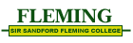
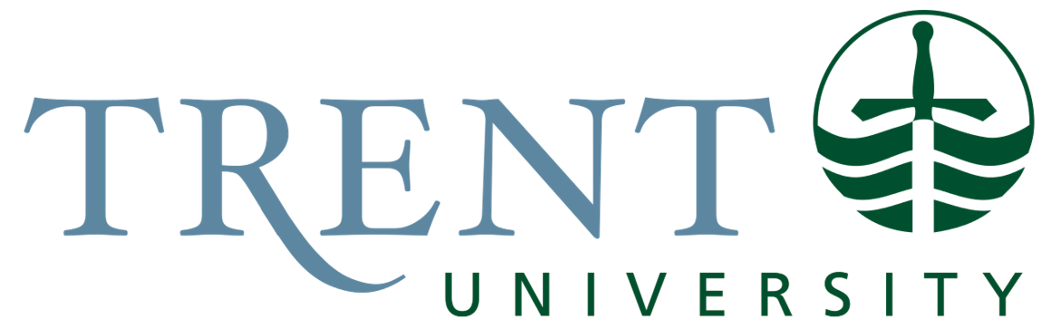

Course code: ASLA 1001H

Deaf Awareness pre-unit quiz

(Punyaja Mishra) (09 September 2022)
Instructions: Circle the best answer (some will have more than one).

- What is American Sign Language (ASL)? (circle two answers)

  - a visual form of English
  - a language that relies on mime
  - a language capable of expressing abstract idea
  - a language using picture-like gestures to express ideas and concepts
  - a language utilizing space and movement to convey meaning

- Historically, American Sign Language is related to:

a) British Sign Language
b) Swedish Sign Language
c) French Sign Language
d) German Sign Language

- American Sign Language is used by most Deaf people in which of the following countries? (Circle two answers)

a) Canada
b) United States
c) Mexico
d) Brazil

- Approximately what percent of Deaf people who marry are married to other Deaf people?

a) 10 percent
b) 25 percent
c) 50 percent
d) 75 percent
e) 90 percent

- American Sign Language is traditionally handed down from generation to generation through:

a) Deaf family members
b) Deaf Adults in the community
c) Residential Schools for the Deaf
d) Sign Language teachers.
e) Classroom teachers

- The role of facial expressions, head movements, and eye gaze in American Sign Language is primarily:

a) Grammatical
b) Stylistic
c) Emotive

- While watching another person sign, it is appropriate to focus on the signers’

  - Hands
  - Chest area
  - Face

- Among ASL signers, fingerspelling is mainly used in what way?

  - Interchangeably with any sign
  - To specify brand names
  - As an artistic from of signing
  - To give names of people and places

- ASL makes use of the space in front of a signer’s body to: (circle all that apply)

  - Convey distance
  - Contrast two people, places, things or idea
  - Express time concepts
  - To indicate sentence types

- To get the attention of a Deaf person who is looking the other way, you should:

a) Yell as loud as you can
b) Tap him/her on the shoulder
c) Wave in his/her face
d) Go around and stand in front of the person

- If your path is blocked by two signers conversing with each other, you should:

- Wait until they stop talking before you pass through
- Bend down very low in order to avoid passing through their signing space
- Go ahead and walk through
- Find another path

- Which of the following are considered rude by Deaf people? (Circle two answers)

- Moving a person aside so you can pass through
- Watching a signed conservation
- Describing a distinctive feature of a person to identify him/her
- Talking (using voice) in the presence of Deaf people

- In general, the least effective communication strategy between Deaf and Hearing people is:

a) Speech and lip-reading
b) Using Sign Language
c) Writing back and forth
d) Using interpreters

- Which of the following are valued in the Deaf community? (circle all that apply)

  - For Deaf people to govern their own affairs
  - Being kept informed about the community and its members
  - Restoration of hearing loss
  - Ability to speak well
  - To have a sense of social obligation and duty to the group
  - To develop long term relationships
  - To be self-reliant (be your own person)

- Other than the word “deaf” a culturally appropriate way to identify Deaf People would be say they are:

  - Deaf and dumb
  - Deaf mutes
  - Hearing impaired
  - Deaf and Hard of Hearing
  - All of the above
  - None of the above

As you go through the Signing Naturally workbook and read the Grammar and Culture/Language Notes, you will learn more about ASL and Deaf Culture.

